LAB -5

Name : Afreen Anz

USN: 1BM23CS016

1. Fibonacci using recursion
2. #include <stdio.h>
3. int fib (int n);
4. int main() {
6. int n, result;
7. printf("\nEnter number: ");
8. scanf("%d", &n);
9. result = fib(n);
10. printf( "%dth number of fibonacci series is %d" , n, result);
11. }
12. int fib(int n){
13. if (n == 1){
14. return 0;
15. }
16. else if (n == 2){
17. return 1;
18. }
19. else {
20. return fib(n - 1) + fib(n - 2);
21. }
22. }

Output:

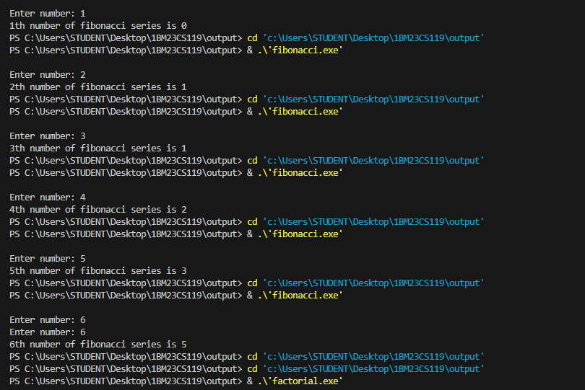

2. Factorial using recursion

#include <stdio.h>

int fact (int n);

int main() {

    int n, result;

    printf("\nEnter number: ");

    scanf("%d", &n);

    result = fact(n);

    if (n<0){

        printf("Undefined for negative numbers!");

    }

    else {

    printf( "factorial of %d = %d" , n, result);

    }

}

int fact( int n){

    if ((n == 0) || (n == 1)){

        return 1;

    }

    else {

        return n \* fact(n - 1);

    }

}

Output:

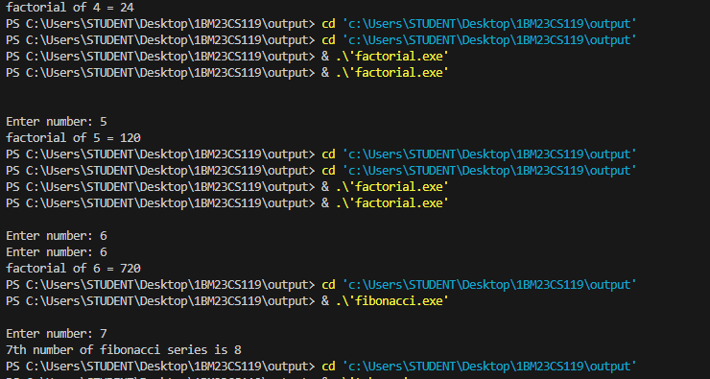

3. Tower of Hanoi using recursion

#include <stdio.h>

void TOH(int n, char s, char t, char d) {

    if (n == 1) {

        printf("Move Disk %d from %c to %c\n", n, s, d);

        return;

    }

    TOH(n - 1, s, d, t);

    printf("Move disk %d from %c to %c\n", n, s, d);

    TOH(n - 1, t, s, d);

}

void main() {

    int n = 3;

    TOH(n, 'A', 'B', 'C');

}

Output:

